**Nodes Management Assignment Documentation**

**Git Repository:**

[**https://github.com/uday-chowdary018/NodesManagementAssignment.git**](https://github.com/uday-chowdary018/NodesManagementAssignment.git)

**Project Overview**

The Node Magagement Assignment is a sprint Boot application that allows uploading data via CSV files or throught a REST API. This application validates the data and stores it in a database.

**Technologies Used:**

* Java
* Spring Boot
* Mysql
* Postman(API Testing Tool) **Endpoints:**

**1. Upload CSV File:**

* **Method:** POST
* **URL:**<http://localhost:8080/api/nodes/uploadcsv>
* **File Formats**: Multipart file (‘file’)

**File upload:** Uploads a CSV file containing node data. The file has valid data. Then nodes are created in database.

* **Request**: In postman o Body->Form-Data->file(type: multipart) and select csv

file

* **Response:**

o Status: 200 Ok -> “csv file imported successfully”

**400 Bad Request:** if there are validation errors in the csv data o Example: NodeName is null o Response:

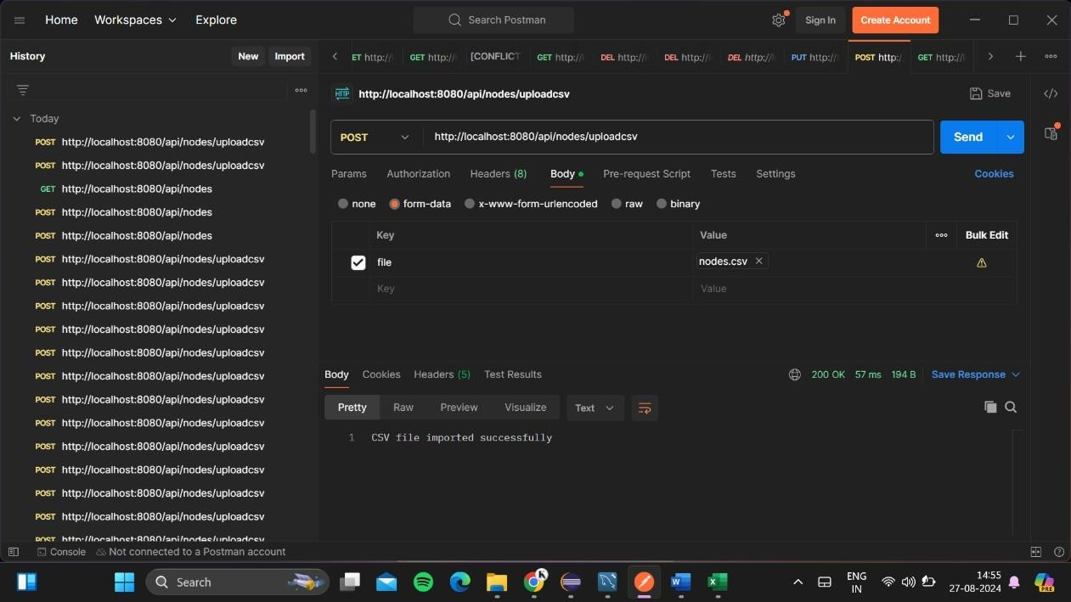

["Node name: 1 Node name cannot be null",...]

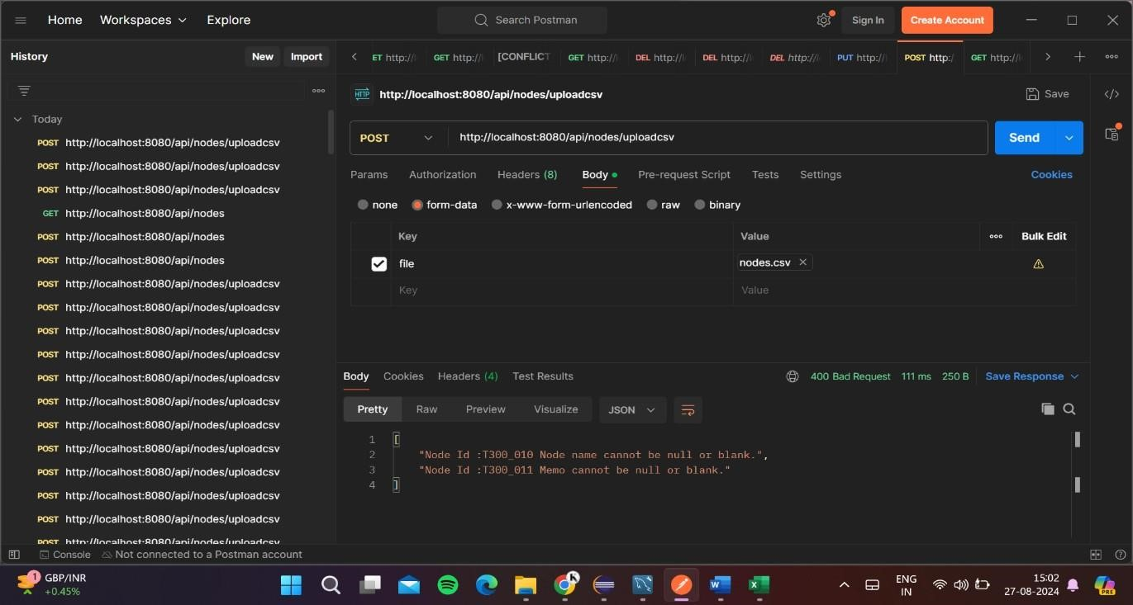

**2. Get All Nodes:**

* **Method : GET**
* **URL:** [**http://localhost:8080/api/nodes**](http://localhost:8080/api/nodes)
* **Response:** It fetch the list of nodes

**3.**

**Create Node:**

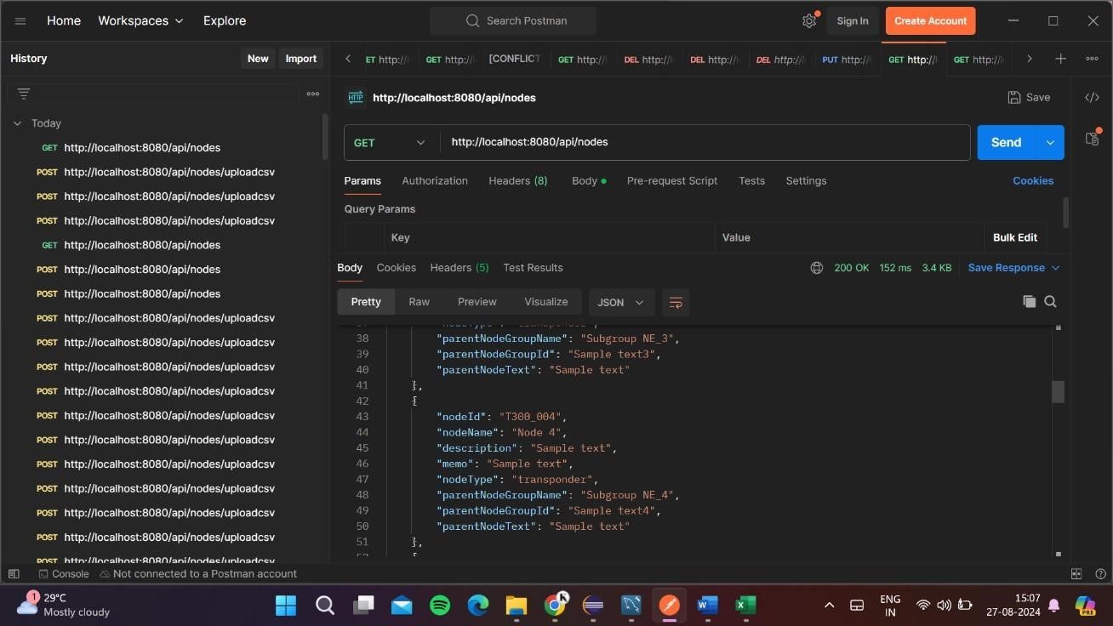

**Method :**



POST



**URL:**



[**ttp://localhost:8080/api/nod**](http://localhost:8080/api/nodes)

[**e**](http://localhost:8080/api/nodes)

[**h**](http://localhost:8080/api/nodes)



[**s**](http://localhost:8080/api/nodes)

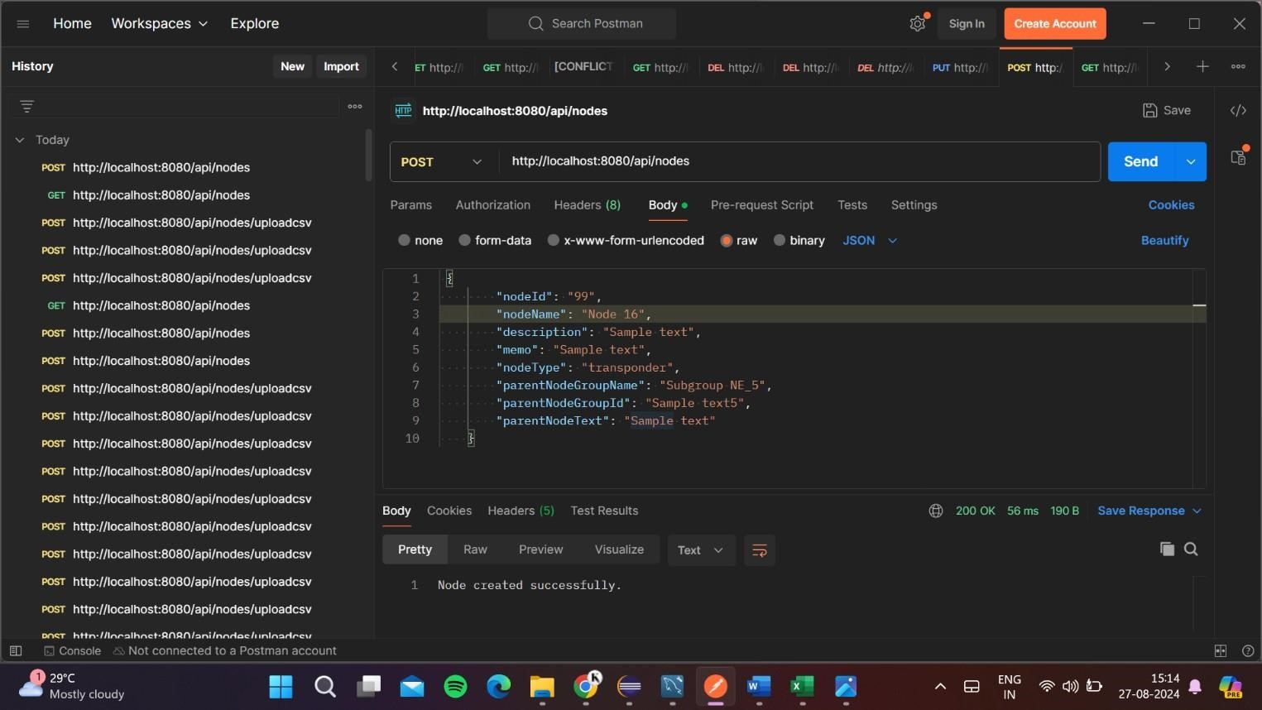

**CSV File**

Node name Parent node group name Parent node group

Node ID Description Memo Node type Id

Sample Sample text

T300_001 Node 1 text transponder Subgroup NE_1 Sample text1

|  |  |  |  |
| --- | --- | --- | --- |
| T300_002 Node 2 | Sample  text | transponder Subgroup NE_2 | Sample text2 |
| T300_003 Node 3 | Sample  text | Sample text transponder Subgroup NE_3 | Sample text3 |
| T300_004 | Sample  text | Sample text transponder Subgroup NE_4 | Sample text4 |
| T300_005 Node 5 | Sample  text | Sample text transponder Subgroup NE_5 | Sample text5 |
| T300_006 Node 6 | Sample  text | Sample text transponder Subgroup NE_6 | Sample text6 |